IN THE HIGH COURT OF DELHI AT NEW DELHI
(CIVIL ORIGINAL JURISDICTION)
C.M. No. 18416 of 2011
IN
Writ Petition (Civil) No. 13698 Of 2009
Public Interest Litigation

In the matter of:

Dr. K. B. Saxena & Ors. …Petitioners
Versus

Union of India & Ors. …Respondents

BRIEF REJOINDER AFFIDAVIT ON BEHALF OF THE PETITIONERS TO THE AFFIDAVIT FILED BY THE UNION OF INDIA
I, Dr. Jacob M Puliyel S/o Late Shri P. M. Mammen, Head, Dept. of Pediatrics, St. Stephens Hospital, Tis Hazari, New Delhi-110054, do hereby solemnly state and affirm as under:
- That I am the Petitioner No. 8 in the above writ petition and being conversant with the facts and circumstances of the case, am competent to swear this Affidavit. I have also been authorized by other petitioners to file this affidavit on their behalf.

- Petitioners had filed the above writ petition highlighting how in the absence of a rational evidence-based vaccine policy, newer and newer vaccines are being pushed into the public health system at the behest of pharmaceutical industry and international bodies like World Health Organization (WHO). Petitioners had specifically challenged the proposed introduction of Pneumococcal, Hepatitis B, Hib and Pentavalent vaccines into the country’s Universal Immunization Programme.

- Petitioners have filed the above application putting on record the recent disturbing developments and seeking specific direction pursuant to the earlier orders of this Hon’ble Court passed in the above proceedings. This Hon’ble Court was pleased to issue notice on the above application. Now the Government of India has filed its response to the above application. Petitioners have gone through the same and submit their reply as given below. Petitioners crave liberty not to file a para-wise reply.

- The vaccine policy framed by the Government is totally contrary to letter and spirit of the orders passed by this Hon’ble Court. This Hon’ble Court had vide order 07.04.2010 had stated the following: “A vaccine policy has been framed by some experts (it appears on page 211 of the paper book). The Respondents may examine the policy for framing similar or other guidelines, whenever it becomes necessary at some stage.”

- On 15.09.2010, this Hon’ble Court inter-alia recorded in the order: “At this juncture, Mr. Prashant Bhushan submitted that the committee has to keep in view the four vital aspects:-
- Incidents of disease in India and its effect potentially,
- The efficacy of the vaccine to prevent the disease as prevention is better than cure,
- The side effects of the vaccine, the nature of adverse side effects and the approximate statistics of the persons who are likely to be effected by such side effects and
- The costs factor.”

- This Hon’ble Court on 08.12.2010 stated: “Let the policy be finalized within two months from today.” Thereafter, on 23.02.2011, this Hon’ble Court stated: “Petitioner No. 8 can file additional comments including all the objections that have been raised in the writ petition within three weeks hence, if not yet filed. It is submitted by the learned counsel for the respondent- Union of India that the policy shall be finalized within two months.”

- Therefore, respondents had to comply with certain direction given from time to time by this Hon’ble Court. The same has not been done as detailed in the application.

- The Government has vouched for the safety and efficacy of the Pentavalent vaccine without the “study” underway in 2 states is even complete. This shows that Government has prejudged the issue and is also not interested in monitoring the after-effects of the administration of vaccine on children in 2 states at huge cost to the public exchequer.

- It is surprising that Government has completely ignored serious reports of deaths and adverse side-effects of Pentavalent in countries like Japan and Pakistan. Reports from the above two countries are annexed as Annexure A25 and Annexure A26 respectively.

- Government has launched a cover-up after a child died due to administration of Pentavalent in Kerala. News report on this is annexed as Annexure A27. The post-mortem report of the girl infant who died clearly stated that she died due to reaction to the injection. The said report is annexed as Annexure A28.

- After these developments petitioner no. 8 Dr. Jacob Puliyel (Member, NTAGI) had written to the Health Secretary apprising him of the recent disturbing developments. The Health Secretary was also requested to intervene in the above matter and call for a full meeting of NTAGI. A copy of the said letter is annexed as Annexure A29.

- NTAGI has itself stated: “As the vaccine has not been introduced there is not enough data on vaccine safety therefore the vaccine should be initially used in the states with better AEFI management and surveillance system to monitor the vaccine safety… The Core committee recommendation on Pentavalent vaccine were discussed and based on the recommendation the committee members felt that the vaccine should be introduced in selected few well performing states and further roll out should be based on the impact assessment of the vaccine including safety aspects… Pentavalent vaccine to be introduced in Immunization programme in the states of Tamil Nadu and Kerala. Thereafter data may be reviewed after 1 year of introduction before expanding the vaccine to other states.”

- Hence, AEFI (Adverse Effects Following Immunization) was a serious concern for even NTAGI, and therefore the need was to monitor the AEFI in the above 2 states. Not only the said effects are not being monitored, even the death of a child is being ignored. Government has not only publically said that the death is not related to the vaccine, but has also in its affidavit has said that the study is being conducted “to dispel the fear of increased AEFI due to Pentavalent vaccine unnecessarily created, perpetuated by petitioner 8.” This shows that Government has prejudged the issue. The Government through its affidavit has made clear that it has no intention of following the NTAGI recommendation to monitor the side-effects of the vaccine. Therefore, this Hon’ble Court should direct the Government to do the same.

- Since the Government appoints NTAGI members without any fair process or transparency, most of them toe the Government’s line. With the Government being adamant in pushing for newer expensive vaccines that would only benefit big pharmaceutical companies, there is no way that NTAGI would come to a different conclusion, as its past history shows. Government has made personal allegations against petitioner no. 8 who is a Member of NTAGI. This shows how dissenting voices are dealt with. Government has also opposed any videographing of the NTAGI meetings.

DEPONENT
VERIFICATION
I, the deponent above-named, do hereby verify that the contents of the above affidavit are true to my knowledge, no part of it is false and nothing material has been concealed therefrom.
Verified at New Delhi on day of February 2012.
DEPONENT
Annexures
  - http://www.japantimes.co.jp/text/nn20110305x3.html

  - http://tribune.com.pk/story/293191/vaccine-nation-globally-supported-company-is-funding-fatal-polio-shots/

  - http://articles.timesofindia.indiatimes.com/2011-12-17/thiruvananthapuram/30528346_1_pentavalent-vaccine-infant-kerala

  - Post Mortem report death in Kerala Hypersensitivity to injection (see below)

  - Letter to Health Secretary
To
Mr P K Pradhan
The Health Secretary
New Delhi

Dear Sir,
I congratulate you on your appointment as Union Health Secretary and also wish you greetings for the New Year. I write as a member of the National Technical Advisory group on Immunization. There has not been a meeting of the NTAGI for over a year and a half - since 26 August 2010. Two meeting that were scheduled last year were cancelled at short notice. There are a number of issues that need to be discussed and I hope you will address these expeditiously.
1. Reform in NTAGI Selection and Functioning
The constitution of this NTAGI needs urgent reform. The Government has set this up as it needs independent scientific advice. As of now, the Government appoints members to the NTAGI. It is therefore possible for the government to select persons whose viewpoint it is comfortable with, and thereby defeat the very purpose of setting up the independent scientific NTAGI. Also there is a tendency not to record dissenting voices. Taking a vote on the views of the majority as no meaning as the committee is not representative in any way.

2. We need a three member team to regularly recruit experts from qualified applicants to this NTAGI for a fixed term. Term appointment will ensure fresh ideas are introduced regularly. Overlap of tenures can ensure institutional memory and continuity. In this way the Government will get the best advice. Some suggestions for reform were made in the last NTAGI meeting but this needs to be followed up and elaborated.
3. Deaths in Japan and Report of the Pakistan Prime Ministers Inspection Commission
I bring to your attention the recent events related to adverse events with Hib associated combination vaccines in neighboring countries. The deaths in Bhutan, Pakistan and Sri Lanka have been noted in the minutes of the last NTAGI meeting. The effort to gloss over the deaths in Sri Lanka as being ‘unlikely to be related to vaccine’ after changing the vary classification system used for such AEFI where using the standard protocol of the Brighton Collaboration would have led to the conclusion that the vaccine was possibly related to the deaths has been pointed out before.

4. Recently the Prime Ministers Prime Minister’s Inspection Commission (PMIC) on the working of the Expanded Programme on Immunisation (EPI), headed by Dr Malik Amjad Noon, has recommended that Prime Minister Yousaf Raza Gilani immediately suspend the administration of all types of vaccines funded by the GAVI because of deaths and side effects of - among others – the pentavalent vaccine.

5. The commission also drew attention to five deaths have been reported in Japan this year soon after the vaccination was administered while 25 serious adverse reactions, after a Hib combination with DPT.

6. It is ironic that Pakistan, which is more dependent on foreign funding than is India, feels empowered to take an independent stance in the interest of their children, where as we are do not feel able to resist these international pressures.

7. I must point out that according to press reports; GAVI has agreed to fund the full vaccine costs for introduction of Pentavalent vaccine in India for 3 years. Those who have studied GAVI functioning, will know that part payment is a basic guiding principle underlying all its funding – even to the poorest of poor countries. The fact that full funding is on offer for India, is indicative of the serious crisis of confidence internationally with the Pentavalent vaccine and the desperation of GAVI to get it introduced in India. Discernment and prudence would mandate looking with suspicion on this GAVI offer which is completely alien to its standard operating practices.

8. Need for Active Surveillance of Adverse Effects
At the last NTAGI meeting, concerns were raised regarding the safety and efficacy of the Pentavalent Vaccine which was sought to be introduced in India. In view of the adverse events following immunization (AEFI), including deaths, with use of this vaccine in Sri Lanka, Bhutan, and Pakistan, it was decided to introduce the vaccine in two states with better AEFI management and surveillance systems to monitor vaccine safety (Minutes meeting 26/8/10 Agenda item 1). The recommendations state: “Since AEFI is a concern hence same will be monitored and also system(s) will be strengthened so as to ensure immediate management of AEFIs; NCDC (is) to lead this activity.”

9. Accordingly Pentavalent vaccine was introduced in Kerala and Tamil Nadu in the on the 14th and 17th of December 2011 respectively. On the next day, the vernacular press reported a death in a 2 month old health child on the day after vaccination. Initially after the first symptoms of AEFI the parents went with the child to a hospital and were seen and sent home but the child died by next morning. The matter came to public notice only because of the press report.

10. This is a very unsatisfactory situation. We have no system in place to record adverse events and this case would not have been noticed had it not come in the press. The press cannot be expected to report isolated cases of deaths. Vaccine reactions don’t take place routinely. Isolated deaths don’t make it to news papers. We certainly need a better system to actively enquire about side effects. Every child who is vaccinated must be followed up after a week. Even in the USA where there is a well publicized Vaccine Adverse Event Reporting System (VAERS) jointly maintained by the US CDC and the US FDA, according to the FDA-Commissioner David Kessler “only about one percent of serious events ... are reported”. (1) Given that the NTAGI has asked for introduction of the vaccine to look for side effects, every child needs to be followed up actively.

11. You will remember that the Final Report of the Committee appointed by the Govt. of India (vide notification No. V.25011/160/2010-HR dated 15th April, 2010) to enquire into “Alleged irregularities in the conduct of studies using Human Papilloma Virus (HPV) vaccine” by PATH in India (February 15, 2011) noted as follows: “It may be highlighted that 4 of the 5 primary outcome measures proposed in the study related to evaluation of the safety of the vaccine in population setting… There is no dairy card based information record for assessing minor or major AEFI in the study protocol which seems unusual with such a large observational study.”

12. Not to have a system in place an active surveillance of AEFI, for the Pentavalent vaccine in Kerala and Tamil Nadu and to rely on press reports will be inexcusable. Small cluster samples will not provide information on relatively uncommon side effects. Unless we capture all cases, it will not be possible to evaluate harms and benefits.

13. In response to a PIL filed in the Kerala High Court the Government of Kerala has told the court that 40,000 doses of Pentavalent vaccine have been administered in the first month of starting the programme and there were no side effects (as if no child even had fever with the vaccine - leave alone the death already reported in the papers about which the Government's final report is awaited). Such blatant denials, in an affidavit to the court, seriously erode the credibility of the government's stand.
14. I hope you will call a full meeting of the NTAGI to discuss these and related matters

Sincerely

Jacob Puliyel

1. Kessler, DA, the Working Group, Natanblut S, Kennedy D, Lazar E, Rheinstein P, et al. Introducing MEDWatch: a new approach to reporting medication and device adverse effects and product problems. JAMA 1993; 269(21): 2765.

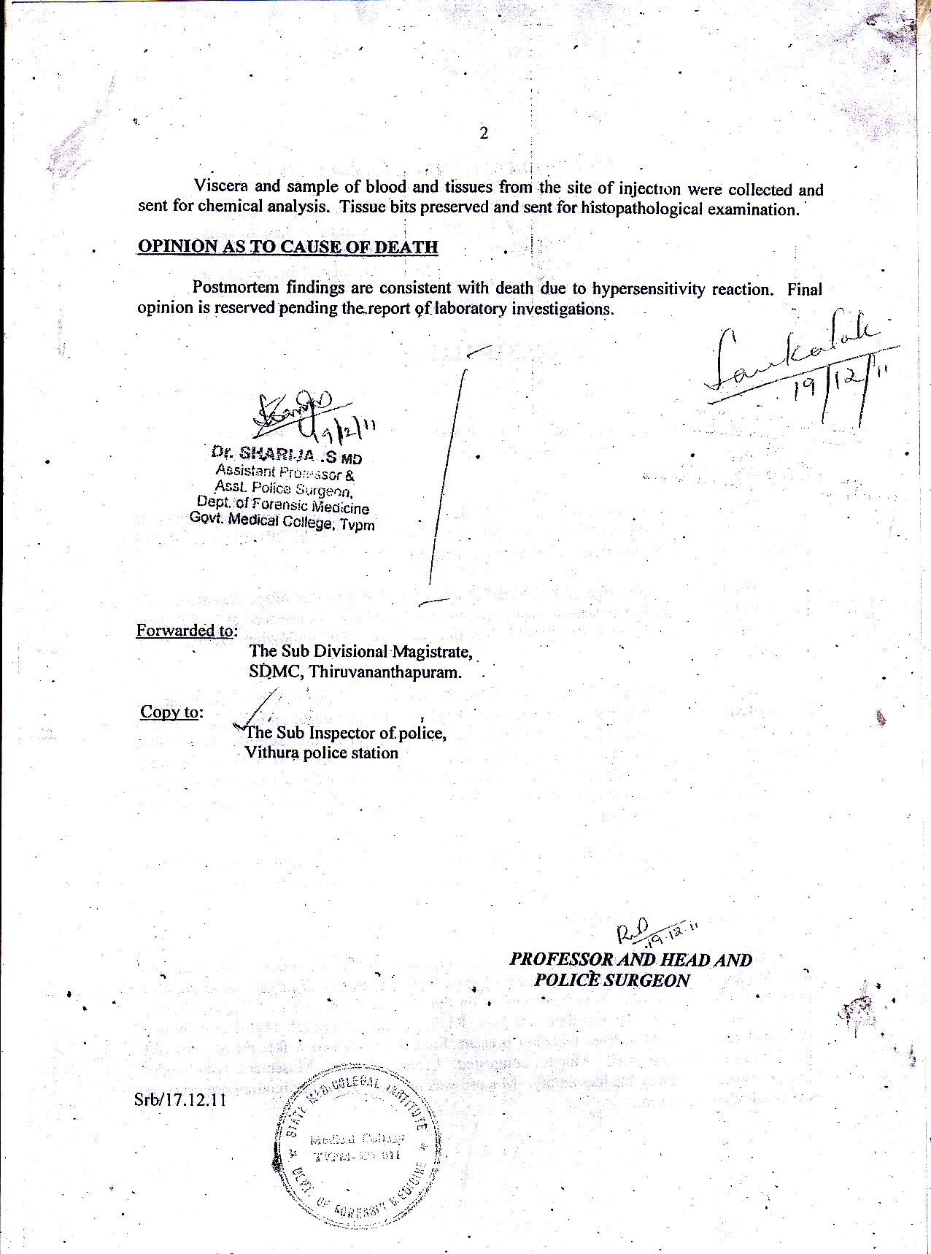

IN THE HIGH COURT OF DELHI AT NEW DELHI
W.P.(C) 13698/2009
DR. K. B SAXENA and ORS ..... Petitioner
Through: Mr.Pranav Sachdeva, Advocate.
versus
UNION OF INDIA and ORS ..... Respondent
Through : Ms.Maneesha Dhir, Ms.Jayashree Shukla
and Mr.Abhirup Dasgupta, Advocate for
UOI.
Ms.Neha Bhatnagar, Advocate for
R-3/ICMR.
CORAM:
HON'BLE MR. JUSTICE SANJAY KISHAN KAUL
HON'BLE MR. JUSTICE RAJIV SHAKDHER
O R D E R
21.03.2012
CM No.18416/2011 (For Ad-interim directions)
A request for adjournment is made on behalf of the petitioner.
List on 30.07.2012.
The parties to complete the pleadings in the meantime.

