IN THE HIGH COURT OF DELHI AT NEW DELHI
(CIVIL ORIGINAL JURISDICTION)

Writ Petition (Civil) No. 13698 of 2009
Public Interest Litigation

In the matter of:

Dr. K. B. Saxena & Ors. …Petitioners
Versus

Union of India & Ors. …Respondents

SUPPLEMENTARY AFFIDAVIT ON BEHALF OF THE PETITIONERS
I, Dr. Jacob M Puliyel S/o Late Shri P. M. Mammen, Head, Dept. of Pediatrics, St. Stephens Hospital, Tis Hazari, New Delhi-110054, do hereby solemnly state and affirm as under:
- That I am the Petitioner No. 8 in the above writ petition and being conversant with the facts and circumstances of the case, am competent to swear this Affidavit. I have also been authorized by other petitioners to file this affidavit on their behalf.

- Petitioners had filed the above writ petition highlighting how in the absence of a rational evidence-based vaccine policy, newer and newer vaccines are being pushed into the public health system at the behest of pharmaceutical industry and international bodies like World Health Organization (WHO). Petitioners had specifically challenged the proposed introduction of Pneumococcal, Hepatitis B, Hib and Pentavalent vaccines into the country’s Universal Immunization Programme.

- Petitioners have filed an application (C.M. 18416/2011) putting on record the disturbing developments and seeking specific directions pursuant to the earlier orders of this Hon’ble Court passed in the above proceedings. This Hon’ble Court was pleased to issue notice on the above application. The Government of India then filed its response to the said application. Petitioners had then in February 2012 filed a detailed rejoinder to the Govt.’s response. The above facts are not being detailed herein for the sake of brevity. Petitioners are filing this supplementary affidavit to bring on record some of the developments that have occurred over the last few months.

- Given the evidence provided to this court of how the NTAGI had recommended the vaccine without taking into consideration the evidence from a multi-centre study done by the ICMR, and several instances of sudden unexplained deaths within 48 hours of receiving Pentavalent vaccine in neighboring countries (Bhutan, Sri Lanka, Pakistan, Japan), the Government promised to set up an ‘Expert committee’ to re-evaluate its decision to introduce Pentavalent vaccine in the country.

- After this re-evaluation the NTAGI, in revised its recommended (Minutes 26 August 2010): “As the vaccine has not been introduced there is not enough data on vaccine safety therefore the vaccine should be initially used in the states with better AEFI management and surveillance system to monitor the vaccine safety” The NTAGI noted that the Government appointed ‘Core committee’ had “felt that the vaccine should be introduced in selected few well performing states and further roll out should be based on the impact assessment of the vaccine including safety aspects…’ The final NTAGI recommendation was “Pentavalent vaccine is to be introduced in Immunization programme in the states of Tamil Nadu and Kerala. Thereafter data may be reviewed after 1 year of introduction before expanding the vaccine to other states.” It is thus evident that AEFI (Adverse Effects Following Immunization) was a serious concern of the Expert Committee, the Core Committee and the NTAGI, and therefore the need to strictly monitor the AEFI in the above 2 states.

- But the Government in its counter had vouched for the safety and efficacy of the Pentavalent vaccine without the “study” underway in 2 states is even complete. In its affidavit Government said that the study is being conducted “to dispel the fear of increased AEFI due to Pentavalent vaccine unnecessarily created, perpetuated by petitioner 8.” This shows that Government has prejudged the issue and is also not interested in monitoring the after-effects of the administration of vaccine on children in 2 states at huge cost to the public exchequer. Petitioners had shown in their rejoinder that Government has completely ignored serious reports of deaths and adverse side-effects of Pentavalent in countries like Japan, Sri Lanka, Bhutan and Pakistan.

- After this petition was filed, the Government of India developed a Standard operating procedure for AEFI. Relevant pages of the SOP are annexed as Annexure A. It details that the Brighton Classification of AEFI must be utilized for uniform reporting. It lists seizures within 3 days, Hypotonic hypo responsive episode (HHE) within 24 hours and Encephalopathy within 3 days as ‘Serious Side Effects’ of DPT vaccine (one of the components of the Pentavalent vaccine). It further states that there would be 570 cases of Seizure, 570 cases of HHE and 20 cases of encephalopathy per 1 million doses of the DPT. The SOP explicitly states that ANMs, HAs and other field level health workers and Medical Officers of Primary Health Centers MO(PHC) should follow-up all children and mothers they vaccinated during the next vaccination session or follow-up field visits (or post and ante-natal visits), to monitor the occurrence of any AEFI.

- The decision to introduce the vaccine in Kerala resulted in agitations across the state against the vaccine. The Government of Kerala set up an expert Group under Dr Noel Narayanana to look into the matter. The Noel committee recommendation specifically states that all vaccinated children are to be monitored for any adverse events at least 48 hours following vaccination. A copy of the said report is annexed as Annexure B. Therefore the NTAGI, the Government’s SOP on AEFI and the Dr. Noel Committee Report for introduction of Pentavalent vaccine, all demand that every child who was vaccine is followed up for side effects and possible death. The SOP clearly gives the rate of serious side effects with DPT – a component of Pentavalent vaccine. If ‘no serious side effects’ are noted with Pentavalent vaccine, it is an indicator of the poor quality of surveillance.

- By various reports it appears there have been at least 7 deaths following pentavalent vaccine. 1 death was reported in the Noel committee report before the government programme started in Mallaparum district. 4 other deaths were reported in the first 2 months of introducing the vaccine in Kerala. 2 deaths are reported from TN making the total of 7 deaths. Given that the surveillance is so poor, that not one case of serious side effects like Seizures and HHE was recorded, it is likely that the 7 deaths is an underestimation of the problem. As vaccines are a special group of drugs given to health children to prevent illness, according to the US FDA, thus vaccine safety is paramount. Thus not even 1 death is acceptable from immunization. An article on this published in Annals of Medicine is annexed as Annexure C. Response received under RTI showing that serious side-effects are not being noted is annexed as Annexure D. News reports and articles on the above issue are annexed as Annexure E (Colly). Petitioner No. 8 who is also a Member of NTAGI had written to the Health Secretary on this issue. His letter dated 10.04.2012 is annexed as Annexure F.

- The Government should therefore be instructed to follow its own SOP and record side effects from each child vaccinated after 48 hours as per the Noel report. Any child who was vaccinated but cannot be traced must be recorded. It is only then that an accurate picture of the safety of the vaccine can be obtained. This was the purpose for which the NTAGI instructed that the vaccine be trialed in 2 well performing states of Kerala and Tamil Nadu which have good surveillance systems in place. In the remaining 6 months the government must be instructed to collect the data as prescribed in its SOP and the Noel Committee and present it to the court.

- In spite of the explicit instructions of the NTAGI that the benefits and harms of Pentavalent vaccine must be studied in 2 states for a year before it is introduced to other states it is proposed to introduce it in 6 states starting in October 2012 well before the data from the 1 year trial is over. According to documents obtained under the RTI, GAVI had threatened to withdraw a grant of US$ 118 500 000 (Rs 529.93 crores). Document received under RTI is annexed as Annexure G. To obtain this grant the country will have to be spent Rs 1372.60 crores. In contrast, the basic immunization programme against 6 killer disease costs less than Rs 600 crores and over 40% of the population does not receive these basic vaccines. This seems to be a blatant attempt to foist the vaccine on the country in the face of the mounting deaths related to the vaccine. Counsel for the petitioner had also written to the Health Secretary in this regard. The said letter dated 20.04.2012 is annexed as Annexure H.

- This Court in the instant case had directed the Government to formulate a rational evidence based vaccine policy. Thereafter a policy that was not even approved by NTAGI and was not in tune with the spirit of the orders of this Hon’ble Court was prepared and published by the Government. An article published in Current Science by two prominent experts in this regard is annexed as Annexure I. The petitioners have challenged the policy in the form of an application in this case. This Hon’ble Court was pleased to issue notice on that application vide its order dated 30.11.2012.

- Thereafter, the Government has stated that the said policy is only a draft and has placed the said draft before NTAGI. Minutes of the NTAGI meeting dated 18.05.2012 are annexed as Annexure J. NTAGI members can give comments and others can also send in their suggestions. Pursuant to this petitioner no. 8 (Member of NTAGI) had written to NTAGI on the draft policy. His submissions are annexed as Annexure K. Submission made by Jan Swasthya Abhiyan which is a network of over 20 health organizations are annexed as Annexure L. That is indeed a welcome step, but the entire exercise should be done in a time-bound manner, because otherwise we are back to the old situation of no policy.

DEPONENT

VERIFICATION
I, the deponent above-named, do hereby verify that the contents of the above affidavit are true to my knowledge, no part of it is false and nothing material has been concealed therefrom.
Verified at New Delhi on 23rd day of July 2012.

DEPONENT

Annexures
- GoI Standard operating procedure for AEFI can be down loaded here: http://jacob.puliyel.com/download.php?id=258
- Noel Committee Report Can be downloaded here
http://jacob.puliyel.com/edit.php?id=264
c) Lucija Tomljenovic & Christopher A. Shaw Human papillomavirus (HPV) vaccine policy and evidence-based medicine: Are they at odds? Annals of Medicine, 2011; Early Online, 1–12

d) RTI reply TN Government (see below)
e) News Reports
1. http://articles.timesofindia.indiatimes.com/2012-07-15/chennai/32684409_1_pentavalent-vaccine-b-and-hib-children-vaccinated
2. http://indiatoday.intoday.in/story/government-gives-go-ahead-to-controversial-vaccine/1/185881.html
3. http://www.ipsnews.net/2012/04/india-serves-up-costly-cocktail-of-vaccines/

4. Arun Ram Times of India Chennai Pentavalent vaccine 'kills' 4 Kerala kids - Times of India Publications
lite.epaper.timesofindia.com/mobile.aspx?

f) Letter to Health Secretary (See below)
g) RTI GAVI and Pentavalent vaccine
No Z.33013/01/2012-CC&V 6 June 2012 (See abstract below)
h) Letter to Health Secretary Mr Prashant Bhushan (see below)
i) Y. Madhavi and N. Raghuram National vaccine policy in the era of vaccines seeking diseases and governments seeing public private partnerships CURRENT SCIENCE, 2012;102, 557-8
http://www.currentscience.ac.in/Volumes/102/04/0557.pdf
j) Draft Minutes NTAGI 18/5/12 (see below)
k) Submission to Health Secretary on revision of Policy (see below)
l) Jan Swasth Abahayan suggestion for draft policy. (see below)

d) 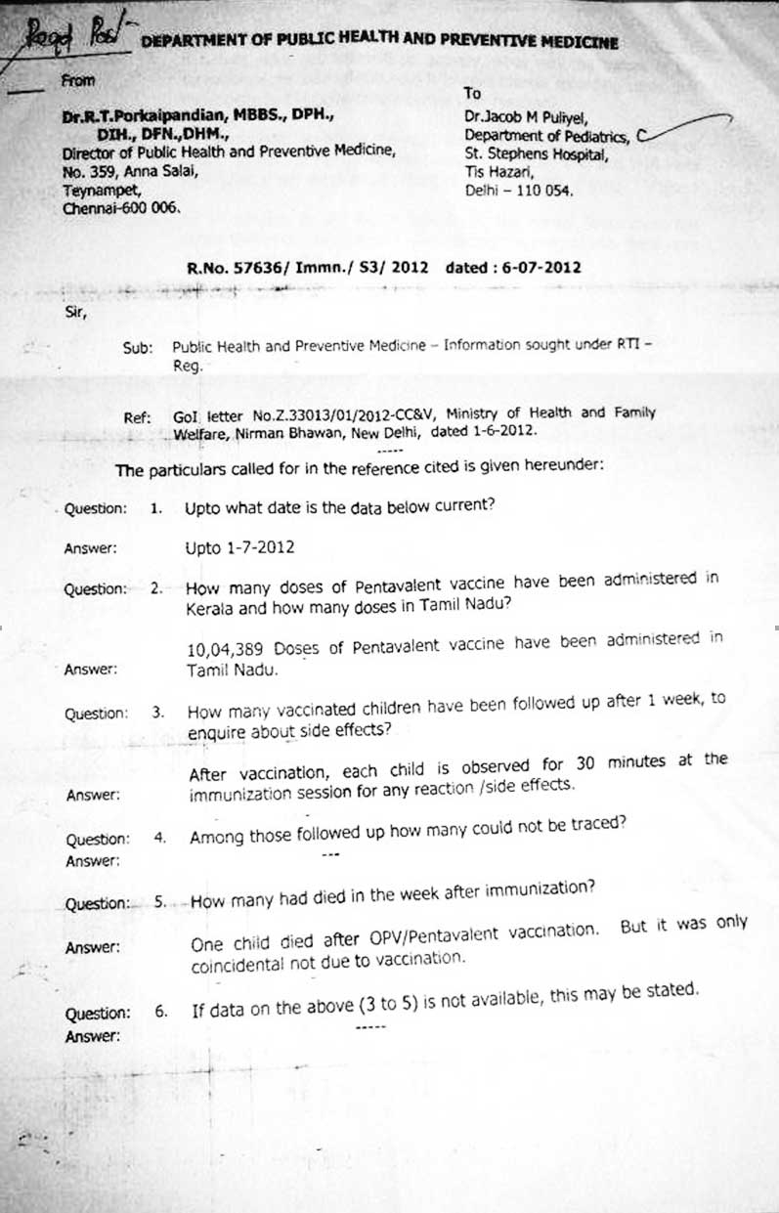
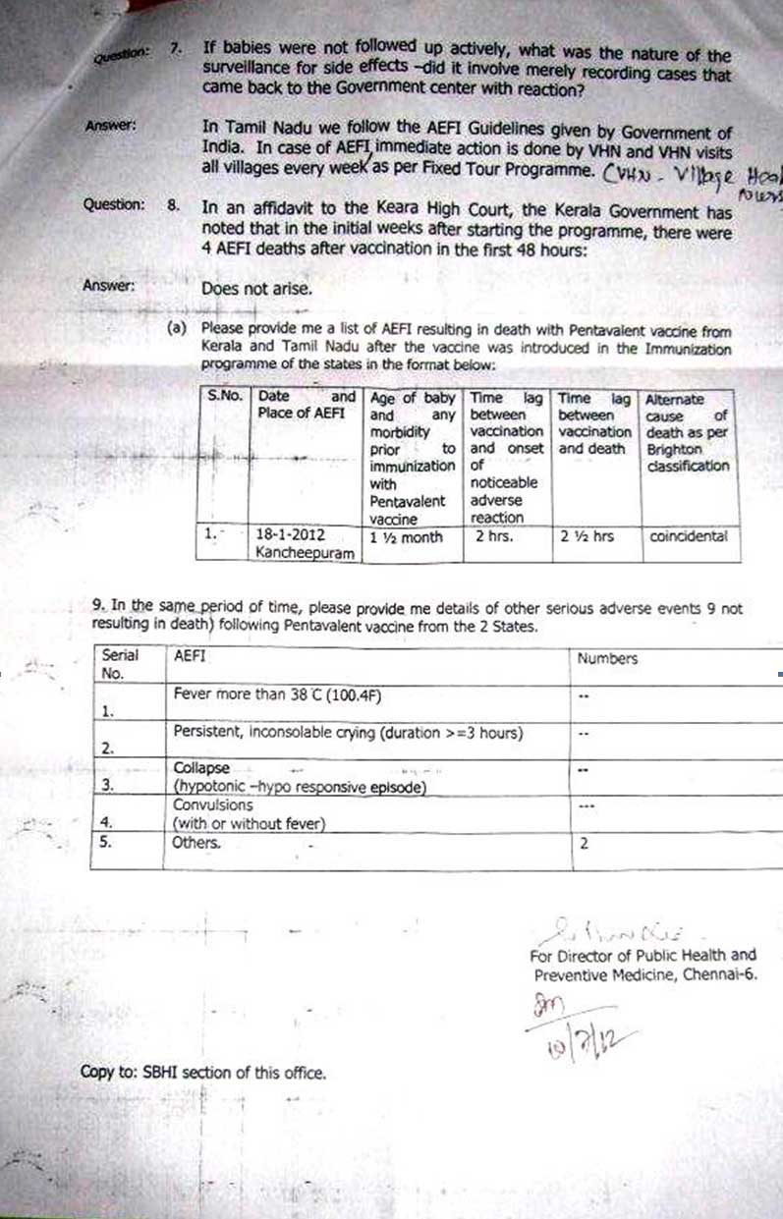
F) Letter to Health Secretary
To
Mr P K Pradhan
The Health Secretary
New Delhi

Dear Sir,
I congratulate you on your appointment as Union Health Secretary and also wish you greetings for the New Year. I write as a member of the National Technical Advisory group on Immunization. There has not been a meeting of the NTAGI for over a year and a half - since 26 August 2010. Two meeting that were scheduled last year were cancelled at short notice. There are a number of issues that need to be discussed and I hope you will address these expeditiously.
1. Reform in NTAGI Selection and Functioning
The constitution of this NTAGI needs urgent reform. The Government has set this up as it needs independent scientific advice. As of now, the Government appoints members to the NTAGI. It is therefore possible for the government to select persons whose viewpoint it is comfortable with, and thereby defeat the very purpose of setting up the independent scientific NTAGI. Also there is a tendency not to record dissenting voices. Taking a vote on the views of the majority as no meaning as the committee is not representative in any way.

2. We need a three member team to regularly recruit experts from qualified applicants to this NTAGI for a fixed term. Term appointment will ensure fresh ideas are introduced regularly. Overlap of tenures can ensure institutional memory and continuity. In this way the Government will get the best advice. Some suggestions for reform were made in the last NTAGI meeting but this needs to be followed up and elaborated.
3. Deaths in Japan and Report of the Pakistan Prime Ministers Inspection Commission
I bring to your attention the recent events related to adverse events with Hib associated combination vaccines in neighboring countries. The deaths in Bhutan, Pakistan and Sri Lanka have been noted in the minutes of the last NTAGI meeting. The effort to gloss over the deaths in Sri Lanka as being ‘unlikely to be related to vaccine’ after changing the vary classification system used for such AEFI where using the standard protocol of the Brighton Collaboration would have led to the conclusion that the vaccine was possibly related to the deaths has been pointed out before.

4. Recently the Prime Ministers Prime Minister’s Inspection Commission (PMIC) on the working of the Expanded Programme on Immunisation (EPI), headed by Dr Malik Amjad Noon, has recommended that Prime Minister Yousaf Raza Gilani immediately suspend the administration of all types of vaccines funded by the GAVI because of deaths and side effects of - among others – the pentavalent vaccine.

5. The commission also drew attention to five deaths have been reported in Japan this year soon after the vaccination was administered while 25 serious adverse reactions, after a Hib combination with DPT.

6. It is ironic that Pakistan, which is more dependent on foreign funding than is India, feels empowered to take an independent stance in the interest of their children, where as we are do not feel able to resist these international pressures.

7. I must point out that according to press reports; GAVI has agreed to fund the full vaccine costs for introduction of Pentavalent vaccine in India for 3 years. Those who have studied GAVI functioning, will know that part payment is a basic guiding principle underlying all its funding – even to the poorest of poor countries. The fact that full funding is on offer for India, is indicative of the serious crisis of confidence internationally with the Pentavalent vaccine and the desperation of GAVI to get it introduced in India. Discernment and prudence would mandate looking with suspicion on this GAVI offer which is completely alien to its standard operating practices.

8. Need for Active Surveillance of Adverse Effects
At the last NTAGI meeting, concerns were raised regarding the safety and efficacy of the Pentavalent Vaccine which was sought to be introduced in India. In view of the adverse events following immunization (AEFI), including deaths, with use of this vaccine in Sri Lanka, Bhutan, and Pakistan, it was decided to introduce the vaccine in two states with better AEFI management and surveillance systems to monitor vaccine safety (Minutes meeting 26/8/10 Agenda item 1). The recommendations state: “Since AEFI is a concern hence same will be monitored and also system(s) will be strengthened so as to ensure immediate management of AEFIs; NCDC (is) to lead this activity.”

9. Accordingly Pentavalent vaccine was introduced in Kerala and Tamil Nadu in the on the 14th and 17th of December 2011 respectively. On the next day, the vernacular press reported a death in a 2 month old health child on the day after vaccination. Initially after the first symptoms of AEFI the parents went with the child to a hospital and were seen and sent home but the child died by next morning. The matter came to public notice only because of the press report.

10. This is a very unsatisfactory situation. We have no system in place to record adverse events and this case would not have been noticed had it not come in the press. The press cannot be expected to report isolated cases of deaths. Vaccine reactions don’t take place routinely. Isolated deaths don’t make it to news papers. We certainly need a better system to actively enquire about side effects. Every child who is vaccinated must be followed up after a week. Even in the USA where there is a well publicized Vaccine Adverse Event Reporting System (VAERS) jointly maintained by the US CDC and the US FDA, according to the FDA-Commissioner David Kessler “only about one percent of serious events ... are reported”. (1) Given that the NTAGI has asked for introduction of the vaccine to look for side effects, every child needs to be followed up actively.

11. You will remember that the Final Report of the Committee appointed by the Govt. of India (vide notification No. V.25011/160/2010-HR dated 15th April, 2010) to enquire into “Alleged irregularities in the conduct of studies using Human Papilloma Virus (HPV) vaccine” by PATH in India (February 15, 2011) noted as follows: “It may be highlighted that 4 of the 5 primary outcome measures proposed in the study related to evaluation of the safety of the vaccine in population setting… There is no dairy card based information record for assessing minor or major AEFI in the study protocol which seems unusual with such a large observational study.”

12. Not to have a system in place an active surveillance of AEFI, for the Pentavalent vaccine in Kerala and Tamil Nadu and to rely on press reports will be inexcusable. Small cluster samples will not provide information on relatively uncommon side effects. Unless we capture all cases, it will not be possible to evaluate harms and benefits.

13. In response to a PIL filed in the Kerala High Court the Government of Kerala has told the court that 40,000 doses of Pentavalent vaccine have been administered in the first month of starting the programme and there were no side effects (as if no child even had fever with the vaccine - leave alone the death already reported in the papers about which the Government's final report is awaited). Such blatant denials, in an affidavit to the court, seriously erode the credibility of the government's stand.
14. I hope you will call a full meeting of the NTAGI to discuss these and related matters

Sincerely

Jacob Puliyel

- Kessler, DA, the Working Group, Natanblut S, Kennedy D, Lazar E, Rheinstein P, et al. Introducing MEDWatch: a new approach to reporting medication and device adverse effects and product problems. JAMA 1993; 269(21): 2765.
G) T 22011/1/2011-Imm
Subject: Expansion of Pentavalent Vaccine under Universal Immunization Programme – reg
Notes on pre-page may kindly be referred to:
PUC is a letter dated 26.04.2011 (bearing reference No GAVI/11/119/rk/sc) from Ms Helen Evans, Interim Chief Executive Officer, GAVI Alliance regarding expansion of Pentavalent Vaccine under Universal Immunization Programme.
- In the aforementioned letter Ms Evans has suggested to get in touch directly with UNICEF Supply Division (copied in here)to agree on vaccine shipment plans and a schedule of deliveries, as per mutual convenience.
- Further it has been confirmed that, according to GAVI’s agreement with UNICEF Supply Division, GAVI will pay for transportation costs directly to the national cold stores. India will be expected to pay for any required taxes, customs, toll or other duties imposed on the supply of vaccines and related supplies procured by UNICEF Supply Division on behalf of GAVI.
- Ms Evans has also stated that GAVI Executive Committee (EC) on 4th November 2010, while endorsing India’s request for introduction of pentavalent vaccine in Tamil Nadu and Kerala had allowed for the possibility for a scale up plan from India to introduce the vaccine in additional states before 30 June 2011. If this is not possible, GAVI will relocate the remaining sum of US$ 118,500.000, from the amount the EC originally approved for India in July 2009 to other countries proposals which are ready to fund
- Ms Evans has assured that GAVI stands committed to support India’s scale up plans to additional States within the financial limit of $ 118,500.000 as approved by the EC and has opined that GAVI should receive the Ministry’s communication by 30th June 2011 on the said matter.
- Meanwhile, a request has also been received from the State of Karnataka (vide letter dated 18.04.2011 from Sh EV Ramanna Reddy, State Health Secretary, Karnataka) to consider their State for Pentavalent Vaccine as the State is performing well in terms of routine immunization coverage rate. Sh Reddy has mentioned that as per the CES, the evaluated DPT-3 coverage in Karnataka is 88.20% while Kerala is marginally better at 88.70% where DPT -3 coverage in Tamil Nadu is 78.60%. Further is has been confirmed that Karnataka is making its efforts to improve RI coverage through regular reviews at State RI core group meetings, periodic review meetings and field monitoring of the programme as per GoI guidelines.
- In view of the above, we may opt for expansion of Pentavalent Vaccine in the Nine States , namely, Himachal Pradesh, Jammu and Kashmir, Karanataka, Andhra Pradesh, Punjab, West Bengal, Maharashtra, Madhya Pradesh, and Goa. It may be relevant to mention that these nine States were earlier considered while preparing the draft EFC Note pertaining to introduction of Pentavalent Vaccine under Universal Immunization Programme.
- Based on the available information, a tentative financial calculation have been projected. There would be an estimated expenditure of Rs 1902.53 Crores towards expansion of Pentavalent Vaccine in the above mentioned nine States. The phasing out of the expansion plan has been envisaged during the entire twelfth five year plan i.e. 2012-13 to 2016-17. The detailed calculation sheet is placed below.
- Cnsidering the financial requirement vis-à-vis the fund arrangements, the division may explore the option of available GAVI Support of US $ 118.50 million (i.e. equivalent to Rs 529.93 Crores @ 1 Us $ = Rs 44.72). The balance requirement of Rs 1372.60 Crores may be met out of the domestic budget.
Submitted please
Sd
(Hitesh Jhangiani)
Financial Analyst
20.05.2011
Prashant Bhushan
Advocate

Resi. Office. Chamber
B-16, Sector-14, Noida C-67, Sector-14, Noida 301, New Lawyers Chamber
Dist. Gautam Budh Nagar Dist. Gautam Budh Nagar Supreme Court Of India
(U.P.) - 201 301 (U.P.) - 201 301, fax: 0120-4512694 New Delhi
Ph : 0120-2512632, 2512693 Ph: 0120-2512523, 2512695 Ph: 011- 23070301,23070645.
Mob: +919811164068 E-mail: prashantbhush@gmail.com

Dated: April 20, 2012

To,
Mr. P K Pradhan
Secretary
Ministry of Health & Family Welfare
Nirman Bhawan,
New Delhi-110001

Subject: Government’s proposal to introduce Pentavalent

Dear Sir,

In December 2009, on behalf of a number of public health experts led by former health secretary, I had filed a writ petition in the Hon’ble High Court of Delhi (WPC 13698/2009) highlighting how irrational vaccines were being arbitrarily introduced and promoted by the Government at the behest of vaccine manufacturers and other vested interests. We drew the attention of the court to plan to introduction of Pentavalent vaccine in the country which is of doubtful utility, unproven efficacy, expensive and reported to have fatal side effects in neighbouring countries. The said petition is pending and numerous orders have been passed by the Hon’ble High Court. We have filed a large number of studies, reports and documents in support of our petition. Files of the case are available with your office.

The Government of India had told the court that it will reassess the recommendation to introduce Pentavalent vaccine. Subsequently the court was given the minutes of the NTAGI meeting of 26 August 2010 which advised the following:
“In the ensuing discussion, concern was raised regarding the safety and efficacy of the Pentavalent vaccine in view of the AEFIs reported following usage of this vaccine in Sri Lanka, Bhutan and Pakistan.---

As the vaccine has not been introduced in India, there is not enough data on vaccine safety therefore; vaccine should be initially used in the states with better AEFI management and surveillance systems to monitor the vaccine safety.

Recommendations:
· Pentavalent vaccine to be introduced in Immunization programme in the states of Tamil Nadu and Kerala.
· Thereafter, data may be reviewed after 1 year of introduction before expanding the vaccine into other states.”
In pursuance of this recommendation, Pentavalent vaccine was introduced in Kerala and Tamil Nadu in December 2011.

On the first day of introducing the vaccine in Kerala a child died of a hypersensitivity reaction. In response to a writ in the Kerala High Court by the mother of the child who died, the Government of Kerala admitted that 4 deaths had been recorded in the first few weeks of starting the programme in Kerala. In none of the deaths was an alternate cause of death found as required by the Brighton classification of AEFI. Co morbidity of malnutrition and a pre-existing heart murmur were reported in 2 children but these are not sufficient cause for death soon after vaccination and the cause of death was probably vaccine related according to the WHO approved Brighton Classification.

However, now a report by PTI suggests the Government proposes to introduce the Pentavalent in 6 more states in October 2012 and that it has approved an outlay of Rs 332.70 crores toward the cost of the vaccine.

This would be a gross violation of the specific recommendation of the advisory body selected by the Government. To introduce this vaccine in other states without assessing the side effects will endanger the lives of the children and would be an unnecessary expenditure.

The NTAGI has not had a meeting since 26 August 2010 and 3 meetings were called off at short notice. I am enclosing the requests for discussing various serious vaccine related matters by one of the NTAGI members.

Under these circumstances I would respectfully urge to desist from introducing Pentavalent without a thorough study of efficacy and side effects in the 2 states, and also urgently convene a meeting of NTAGI to discuss all issues in detail.

Thanking you,
Yours faithfully,

Prashant Bhushan

J) 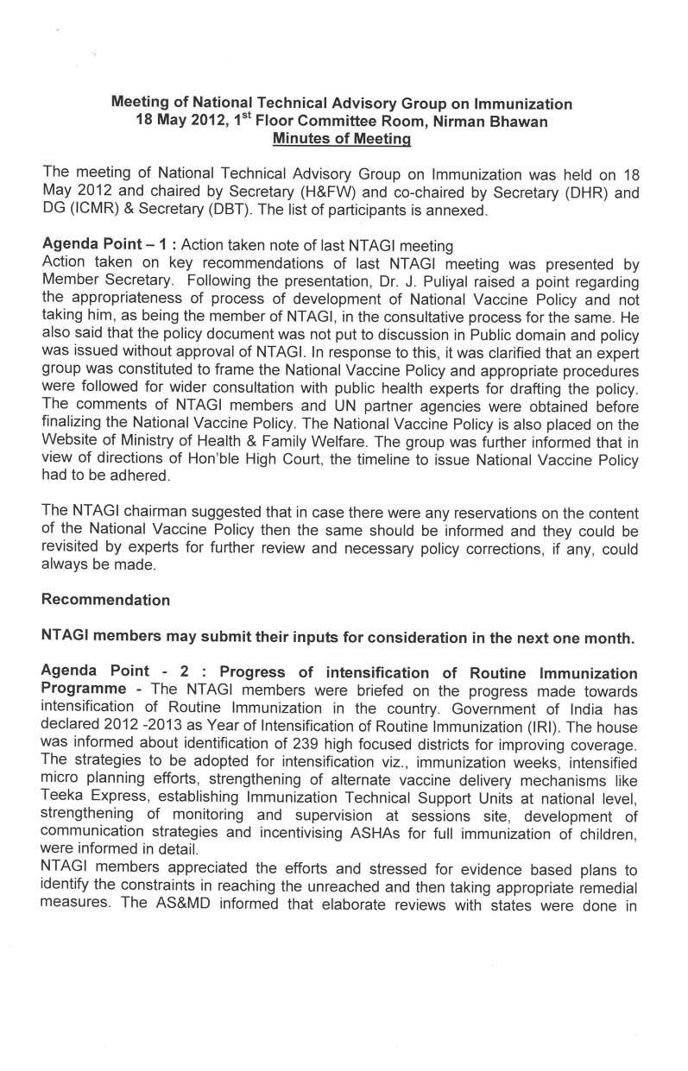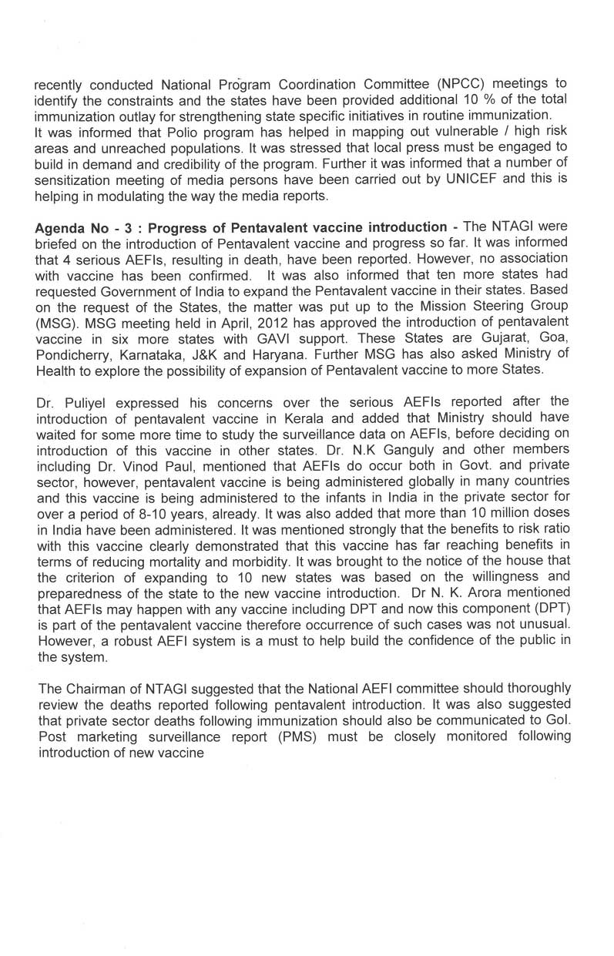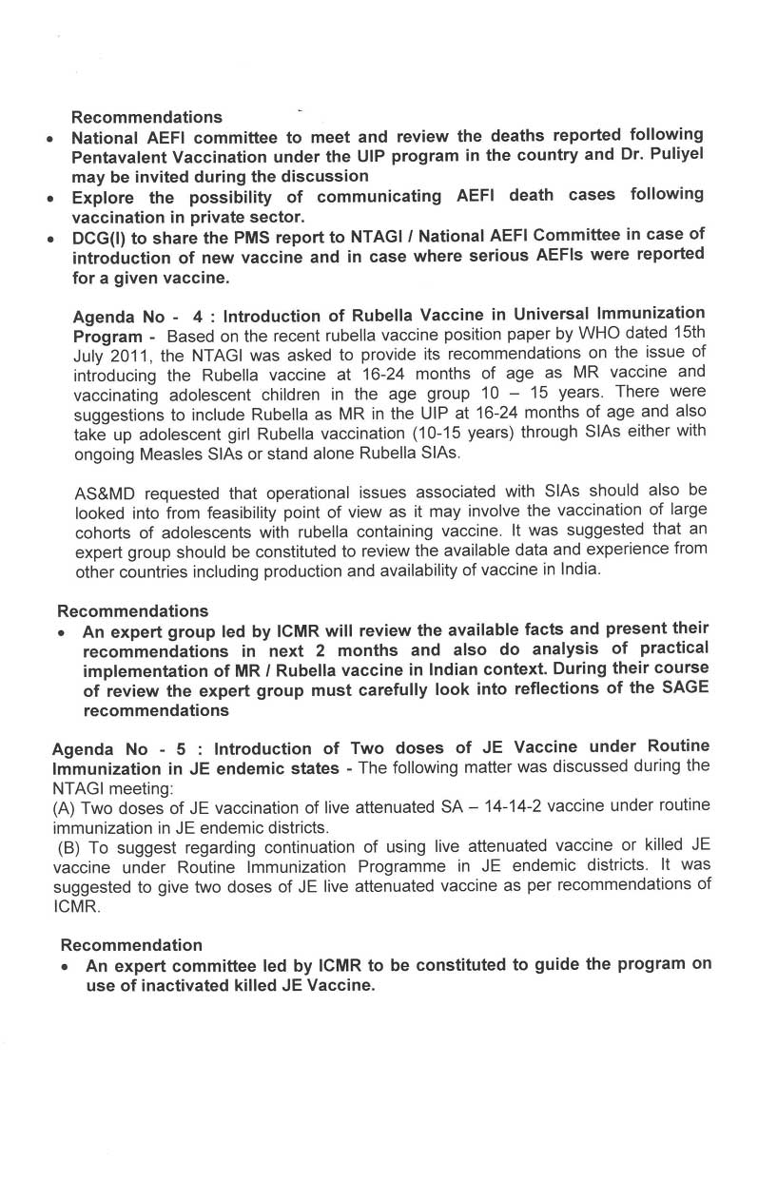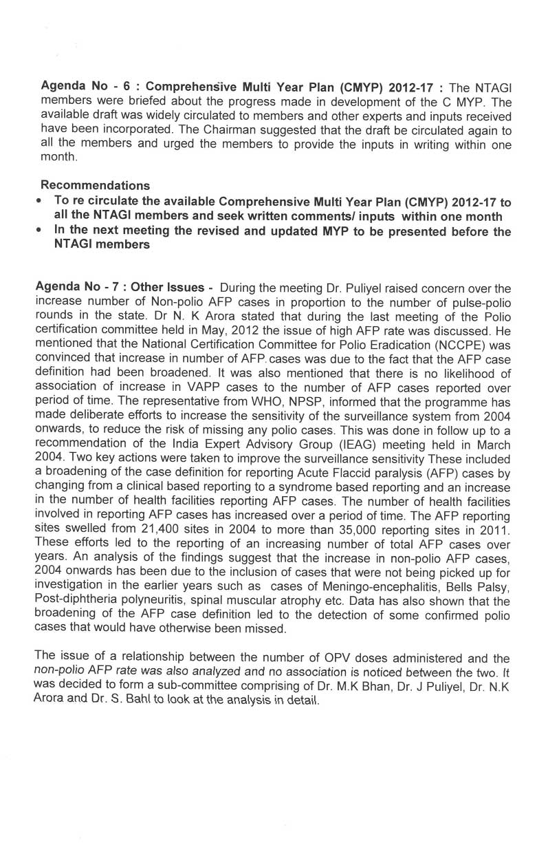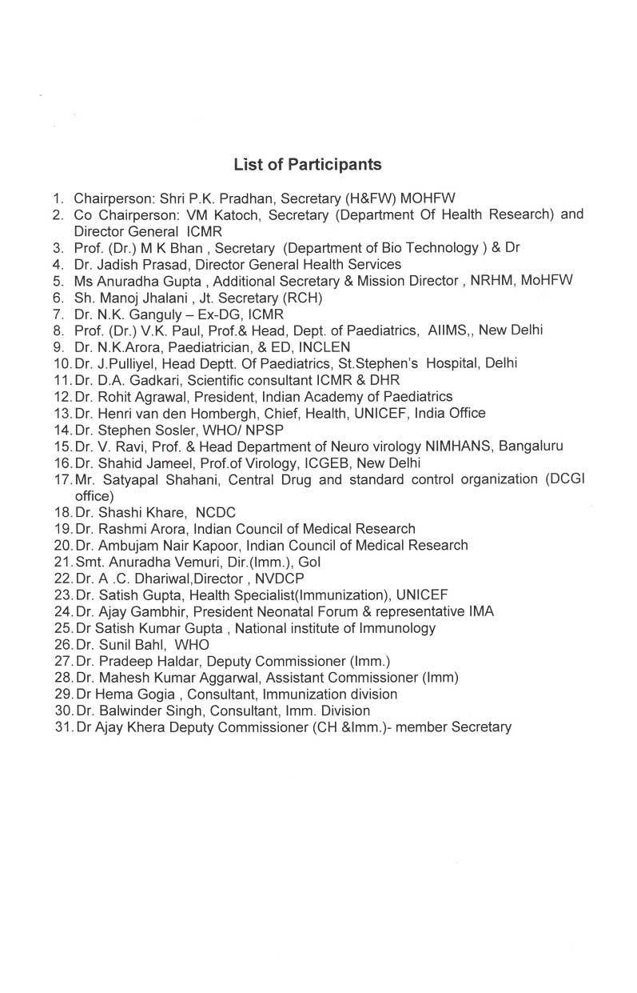
K) Vaccine Policy – A Review and Suggestions
J Puliyel to the Health Secretary

The Ministry of Health and Family Welfare must be commended for its earnestness in developing a National Vaccine Policy. The draft policy document of April 2011 is a concise document that has brought forward many worthwhile ideas. It is also heartening that the ministry is agreeable review the draft policy if it gets serious representations pointing out contentious issues. I will provide a section by section review for your kind consideration
Page 3 Draft Policy Document:
The Executive Summary
This is a concise and pithy statement that summarizes well the various facets to this policy document. It highlights the need for making vaccines available to all, and from there to the future about introducing new vaccines, making sure there is capacity to manufacture store and monitor the adverse effects of new vaccines. It emphasizes the need for absolute safety with vaccines. All this is excellent.
Suggestion for change
The sentence in line 7:
“More and more diseases are becoming vaccine preventable including prominent killers like pneumonia and diarrhea.”
This sentence is a little misleading. There is no vaccine against all causes of pneumonia or diarrhea. The available vaccines are against limited number of strains of one of the many causes of diarrhea namely the Rota virus and against limited number of strains of one of the many causes of pneumonia,– the bacteria Pneumococcus. Vaccine manufacturers sometime misleadingly call these ‘diarrhea and pneumonia vaccines’ but the National Vaccine Policy should be factual.
The sentence could read
More and more vaccines are being produced and the technology is evolving rapidly.
Page 5:
1 Preamble
1.1 The background is described well
Suggestion for change
The sentence “a number of other safe and efficacious vaccines have become available for major killers like pneumonia and diarrhea.” This will have to be revised for making it factual as described above.
The sentence may be changed to read something like:
“New vaccines against some causes of diarrhea and pneumonia are being utilized in many developing and developed countries. “
The efficacy of these vaccines in India needs to be evaluated and it will be putting the cart before the horse if the policy already declares they are safe and efficacious without an evaluation as prescribed in this Policy, without quoting a reference.
1.2 Purpose
This is well stated.
It is about local vaccine needs to guide decision making and develop a long-term plan to strengthen the whole programme and is not about specific vaccines.
2. Policy Context and Framework.
2.1 Current UIP Vaccines
The draft policy states
“However the regular production and supply of these (core UIP vaccines) in a setting where majority of manufacturers are increasingly paying attention to newer vaccines is a big challenge”
The obvious solution to this challenging problem is to follow what the Parliamentary Standing Committee has recommended; to strengthen the Public sector Units so the country is not held to ransom by private units interested only in making highly profitable new vaccines.
Instead the policy inexplicably states in the next line:
“There is limited production capacity of these vaccines in public sector units and the involvement of private sector manufacturers is required to ensure supply of UIP vaccines is not threatened.”
The problem stated relates to private manufacturers not being interested in supplying EPI vaccines except the profitable new vaccines. The prescription to rely more on Private manufacturers seems self defeating.
Suggestion for change
This must be revised to be consistent with the recommendations of the Parliamentary Standing Committee of strengthening the public sector units.
2.2 New and under-utilized vaccines.
This title is unfortunate. Necessary vaccine must be used but the motivation must not be to use all vaccines that are available. It is not correct to say – “the vaccine is under-utilized so it must be utilized more’
The policy states the vaccine is underutilized as the production is limited, prices are high. Then it recommends that ‘the authorities’ should use innovative financing, funding and assured supply mechanisms to overcome these challenges.
As a policy formulation this is extremely vague.
Who are “the authorities” who are to use ‘innovative financing?’
Are they ‘authorities’ related to the Government of India and the Ministry of Health and Family Welfare? This is a “policy of the same Ministry and so is the Ministry instructing itself or permitting itself to use innovative financing?”
Suggestion for change
More clarity is needed when using such terminology which has already come to have some connotations because of the use by GAVI of the same expression. Is the term ‘innovative financing’ to mean what is defined by GAVI or is it merely a generic expression? I suggest that this sentence be deleted unless there is consensus in Parliament that this is the way forward. The issue of ‘sovereign bonds’ as part of the innovative financing mechanism must be taken by the highest bodies because the nation will be mortgaging itself in the process.
2.3 Potentially new vaccines
This is excellent policy to encourage vaccine research within the country for disease prevalent here.
2.4 Vaccine Security and other issues
It is excellent policy to ensure quality safety and efficacy of vaccines and robust regulation.
3. Situation Analysis
3.1 It states that surveillance information for specific vaccine preventable disease is limited.
The Policy inexplicably states that ‘trends in IMR reflect the impact of vaccination’
This is completely unacceptable.
Nearly 50% of the IMR takes place in the first month of life, before most vaccines is even administered. It will be ridiculous to claim in our policy, that the fall in IMR is a good enough surrogate for a fall in vaccine preventable deaths.
Suggestion for change
This sentence must be deleted from the policy. There can be no short cuts to proper surveillance.
4.1.1 Mapping of research capacity
This is excellent Policy
4.1.2 Bio-repositories
The policy requiring proper guidelines is an excellent policy.
4.1.3 Public Private Partnership (PPP)
There will be widespread reservations about the need for including this in Policy.
The policy states that PPP “unifies the commitment of the public sector to develop products to improve health of the population with private sectors discipline and culture in business development and marketing.”
It appears as if the Public sector must develop products (because of its commitment to improve health of the population) and give it to the private sector so they can make the money because of their culture in business and marketing.
“The vaccine industry suffers from lack of support for risky vaccines. …Inputs from IITs etc.. is largely missing. There must be robust mechanisms in place to integrate partnerships in the PPP mode”
PPP is entered into when the public sector does not have the resources or know-how for a project but this is available in the private sector. It is done to make these resources in the private sector available to the public.
Suggestion for change
Transfer of know-how from the public sector to the private sector so thy can profiteer from it (discipline and culture in business development and marketing) cannot be good or even reasonable public policy. It must be deleted from the policy.
4.1.4 Product development for public health emergency
Policy correctly states that there is need to develop mechanisms where speedy regulatory clearances are possible.
However it says “It should be mandatory for the Government to support such developments with Advance Marketing Commitments (AMC) and honor these commitments.”
The term AMC has been coined by GAVI and has a specific meaning so cannot be used in a generic sense. AMC are used only in the context of encouraging manufacture of vaccine against ‘neglected diseases’. It cannot be used it in the context of ‘public health emergencies’.
It is inappropriate that the policy states that future governments must be bound to honor AMC commitments because in such public health emergencies there is no time for the AMC mechanism to be initiated.
Suggestion for change
This needs to be corrected

4.2 Vaccine regulatory systems
This is excellent.
4.3 Vaccine production and supply
This is excellent. The cost of vaccine and delivery are being reckoned correctly.
5. Introduction of new vaccines in UIP
5.1.1
This is unexceptional
5.1.2 Criteria for selection of vaccines for introduction
This crucial policy is stated in the vaguest of terms.
GRADE system is mentioned.
GRADE is a means of giving an alphabetic A, B C etc for quality and strength of evidence.
Suggestion for change
Even the poorest form of evidence gets a ‘GRADE’. Policy must state what level of evidence will acceptable to guide policy decisions. GRADE otherwise has little value.
5.2 Vaccine Formulation and immunization schedules
This is good as it is.
5.3 NTAGI
The sentence
“There is a general perception in India that the time lag from the availability of a vaccine to its use in the NIP should be reduced”
Can this be substantiated? Otherwise I suggest deletion.
Other than this, the formulation is acceptable but does not go far enough.
It lists a number of experts that must be included but it does not suggest how they are to be selected or how they can function in a transparent manner that it inspires confidence.
It must prescribe for example how experts are selected to NTAGI and how to prevent conflicts of interest clouding judgment. A mere declaration of conflicts of interests will not suffice for this. A system that is open to public scrutiny is most likely to ensure that conflicts of interest do not influence decisions.

Suggestion for change
There must be a body of Professors from premier institutions like AIIMS and PGI Chandigarh and the Public Services Commission to select members periodically to this body from among qualified experts. At present eminent persons are invited at the pleasure of the MoHFW and they could all represent the opinions that the MoHFW wants to hear.

5.4 Decision making process
The first two paragraphs are well written.
Suggestion for change
1. It is suggested that people who use the vaccine in the private sector (the more well-to-do) can provide evidence of efficacy and harms that can be translated to the general population. This is fundamentally wrong as the population taking the vaccine through the private system is likely to be better nourished and more resilient. The countries that can afford the vaccine for the entire population, can surly afford to do a proper study in a limited population. This must be undertaken rather than prescribing short-cuts in the Policy.
2. Numerous models of functioning and dysfunctional systems are available from different countries. It would be in the best interest of the country to pick and choose the best in these various models.

USA Model
The meetings of the technical advisory body in the USA are open to the public who may ask questions of the experts. Suggestions for who should be members are sought annually from a variety of sources including the general public. The appointment of members to the Advisory Committee on Immunization Practices (ACIP) in the USA is based on selection from qualified applicants in a transparent process.

UK Model
The UK NICE model allows open evaluation of drugs. The intervention that is being evaluated is first announced to the public. Then the requisite clinical and economic evidence is stringently and critically evaluated and then a draft is drawn for circulation among the stakeholders (public health experts, patients, WHO, industry). After getting inputs from all the stakeholders including manufacturers, the draft is revised based on the said reviews and put up before an independent review panel for final assessment to ensure that all valid viewpoints have been incorporated.
6 Operational Efficiency of UIP
This is well written except that 6.7 in its last line recommend that models to provide expensive vaccine for the poor must be developed:
It states that models must be developed “at least for some vaccines such as pneumococcal conjugate vaccine, rotavirus vaccine and HPV vaccine.”
There are several reasons why this is wrong policy:
a) The policy initially states it will not discuss individual vaccines
b) The policy says a framework for evaluating cost benefit etc must be in place to evaluate new vaccines
c) Pneumococcal vaccine, rotavirus vaccine and HPV have not been studied in this manner in India. It is inappropriate to say that ‘at least’ these vaccines must be provided.
Concluding remarks
Reading through the policy starting with Policy-context and situation-analysis, there seems to be no real policy formulation in the draft National Vaccine Policy. One formulation can be:

“It is the policy of government to make available for the eligible population, free of charge, all vaccines and immunizations that meet the criteria of being cost-effective and affordable, provided that it is the most efficient use of resources (yielding better returns than alternate uses of the resources). These will be evaluated in an open transparent manner.”

Alternative formulations are possible:

“It is the policy of government to make available for the eligible population, free of charge, all vaccines and immunizations that meet the criteria of being effective.”

or

It is the policy of government to make available for the eligible population, at costs, all vaccines and immunizations that meet the criteria of being effective.

The matter of cost-effectiveness is crucial as the alternate formulation looking only at effectiveness but not at cost-effectiveness or affordability is untenable.

There are principles of equity involved. Vaccines must be provided by the state free of charge so that all have equal access to this life saving resource.

Policies relate to the philosophy, mission and goals, while ‘procedures’ say how things will be done – how policies are enacted. It specifies what will be done, when, and by whom.

The policy and procedures are to be judged based on its prescription for transparent evaluation of newer vaccines for efficacy and cost benefit. It must prescribe for example how experts are selected to NTAGI and how to prevent conflicts of interest. A system open to public scrutiny is most likely to ensure this.
These are 2 glaring deficiencies of this draft policy.

I am sure you will consider each of the suggestions on merits and a fresh modified policy would be brought into force soon.

Sincerely

Jacob Puliyel

Jan Swasthya Abhiyan
Health for All - Now! Health is a Basic Human Right!
Addresses for Correspondence:
National Secretariat: c/o Delhi Science Forum, D-158, Lower Ground Floor, Saket, New Delhi -110017.
Ph: (011) 26524323, 26862716 (Telfax). Email: jsasect.delhi@gmail.com
Convenors:
Abhay Shukla
Ajay Khare
Ameer Khan
Amit Sengupta
Amitava Guha
Amulya Nidhi
B.Ekbal
Gouranga Mahapatra
Joe Varghese
Kajal Jain
Rakhal Gaitonde
N.B.Sarojini
Obalesha
Sanjeev Sharma
Sulakshana Nandi
T. Sundararaman
Thelma Narayan
Vandana Prasad
National Co-ordination Committee:
All India People’s Science Network (AIPSN)
All India Drug Action Network (AIDAN)
Asian Community Health Action Network
(ACHAN)
All India Democratic Women’s Association
(AIDWA)
Bharat Gyan Vigyan Samiti (BGVS)
Breast Feeding Promotion Network in India (BPNI)
Catholic Health Association of India (CHAI)
Centre for Community Health and
Social Medicine, JNU
Christian Medical Association of India (CMAI)
Community Health Cell (CHC)
Forum for Creche and Child Care Services
(FORCES)
Fed. of Medical Representative Assns. of India
(FMRAI)
Joint Women’s Programme (JWP)
Medico Friends Circle (MFC)
National Alliance of People’s Movements (NAPM)
National Federation of Indian Women (NFIW)
National Association of Women’s Organisations
(NAWO)
SAMA – Resource Group on Women’s Health
SATHI – CEHAT
Voluntary Health Association of India (VHAI)
Participating Organisations:
Over 1000 organisations concerned with
health care and health policy from both
within and outside the above networks.
14/06/2012
Ref.: JSA/Misc./2012
To,
Sri P. K. Pradhan, Additional Secretary & Mission
Director, NRHM
Ministry of Health and Family Welfare
Nirman Bhawan
New Delhi
Dear Sri P.K.Pradhan
Subject: Comments by Jan Swasthya Abhiyan on
Draft National Vaccine Policy
On behalf of Jan Swasthya Abhiyan, we welcome
the opportunity to provide comments on the draft
National Vaccine Policy. The Jan Swasthya Abhiyan
is a national network of over 20 national and a large
number of state networks and organisations, that are
working in the area of health and pharmaceuticals.
We are attaching our comments and shall be happy
to present the same in person if such an opportunity
can be provided. We look forward to further dialogue
on this issue.
Thanking You,
Yours Sincerely,
(Dr.Amit Sengupta)
for Jan Swasthya Abhiyan
cc. Dr. Ajay Khera,
Member secretary,
National Technical Advisory Group on Immunization
1
Comments by Jan Swasthya Abhiyan on
‘Draft National Vaccine Policy’
Summary
The new Draft National Vaccine Policy of MOHFW 2011, is an outcome of the
ongoing PIL in the Delhi Court against introduction of penta-vaccine in the
Universal Immunization Programme (UIP).
• It lays great emphasis on production of quality vaccines, expediting approval
of new vaccines and introduction of new vaccines in the UIP.
• However, it is not geared to take rational decisions on introduction of a new
vaccine in the Universal Immunization Programme based on its 'need' (actual
disease prevalence, and its burden in relation to other prevailing diseases),
suitability (strain specificity, variation etc.,), safety and efficacy based on
scientific evidences from India and based on cost-benefit and cost-effective
analyses.
• It assumes that all new vaccines are good for Indian population too and all
new vaccines should be introduced in Indian UIP.
• It doesn't make distinction between Universal and non-universal vaccines
(vaccines for selective immunization).
• Its argument about equitable access to new vaccines is misleading when
immunization coverage for existing universal vaccines is only 50% and when
cost-efficacy of the new vaccines has not been established in India
conditions.
• Overall, this policy is meant to justify an agenda that seeks to push all new
vaccines in Indian UIP.
2
Background
National Vaccine Policy (April 2011), available as a booklet with Ministry of Health and
Family Welfare (MOHFW) came to public notice only in mid July when it was released in
a five star hotel in presence of a few members of WHO, National Technical Advisory
Group on Immunization.(NTAGI) and government officials. This policy booklet emerged
in response to a petition filed by civil society and Public Health Academicians against
union Health Ministry on Pentavalent vaccine introduction in Indian UIP in Dec 2009 in
the Delhi High court, alleging that this vaccine is being introduced without proper
studies done in India and that they are being introduced under pressure from WHO,
GAVI and the pharma industry. This PIL sought stay order on the introduction of
pentavalent vaccine till its justification is established. An interim order of Delhi High
court in April 2010 (referring to policy draft prepared during the workshop co-organised
by NISTADS and ICMR) states that the respondents may examine the policy draft
prepared by some experts to prepare guidelines whenever it becomes necessary at
later stage. This policy draft (authored by 36 experts) subsequently published in the
Indian Journal of Medical Research (IJMR), argues for an evidence-based national
vaccine policy for decisions regarding introduction of new vaccines in UIP. The current
new draft national vaccine policy of MOHFW is quite at variance with the scientific
approach adopted in this paper.
It is claimed that this Draft Policy, seeks to streamline the decision-making process on
new and underutilised vaccine introduction, besides addressing issues of vaccine
security, management, regulatory guidelines, vaccine research and development, and
product development. These aspects relate to the production of quality vaccines. They
are welcome. However it is a matter of concern that the Draft Policy does not
emphasize safety or cost-efficacy of vaccines which is of paramount importance from
the Public Health point of view. There are no recommendations about strengthening or
improving or restructuring our disease surveillance system. This lacunae is important
because in India lack of actual prevalence data and lack of cost-benefit evaluation
studies helps the pharma industry to push new vaccines, whether they are needed or
not or whether they are cost-effective or not in Indian conditions.
Its pro-industry tilt is obvious when it fosters rapid introduction of new vaccines,
through “speedy regulatory clearances”. It recommends mechanisms “where the risk of
the manufacturers is cushioned by appropriate assistance from the Government;” and
says that it should be mandatory for the Government to support such developments
3
with Advance Market Commitments and honour the commitments.” Why national
governments are under pressure to commit advance market commitments? It is to be
noted that GAVI gets funding from IFFI, whose funding commitments are based on
donors or speculative loans from capital markets. Speculative bonds to GAVI are based
on advance market commitments from national governments. (Oxfam-MSF report).
Therefore, it is a circular model, where even one break in the link in the chain would
collapse the system.
Policy agenda to push new vaccines lacks scientific evidence
The Draft Policy says “In a situation where there is abundance of new and expensive
vaccines on one hand and limitations of resources on the other, it becomes imperative
that use of vaccines through induction in the Universal Immunization Programme (UIP)
as well as in the free market is done through a framework of decision-making that
confers positive health and economic benefits to the society”. Specifically, the policy
appears to be clearly an agenda to introduce vaccines like Pneumococcal, Rotavirus,
Hib vaccines etc, rather than a guide that justifies the need for above vaccines.
(section 3.1, 3rd para) (section 4 last 5 lines in first para).
For instance, the second para, 4th line of executive summary states, ‘Most of the new
vaccines are used by one segment of the population, which can afford them, while the
most vulnerable segment of the population, which is serviced through the UIP misses
out on the opportunity.’ It is ironical that a government that cannot even cover half of
our children under the UIP or does not have enough government hospitals to treat the
poor, gives ingenious arguments of “equity” and “access” to justify government
spending on bringing expensive new vaccines into UIP (regardless of their disease
burden), saying that the poor can’t afford vaccines that are outside the UIP.
The Draft Policy assumes that all new vaccines are good for Indian population.
Secondly it doesn’t make any distinction between universal and selective vaccines.
The section 3.1 on burden of Vaccine Preventable Diseases (VPDs) and Surveillance
only talks about impact studies of vaccines or monitoring of vaccine preventable
disease surveillance. While this surveillance is an important tool to judge the
effectiveness of the vaccine, the absence of the strategies to find out the relative
disease burden only reflects the eagerness of the policy makers to introduce more new
vaccines rather than first establishing their need, suitability, safety, efficacy in Indian
population.
4
Introduction of new vaccines in UIP
Section 5 appears to have considered some principles before their introduction in UIP
such as disease burden, disease prevalence etc. However the whole purpose of having
an evidence based policy gets defeated by statements such as ‘modeling studies and
data from countries with either geographical proximity or similar demography may also
be used for these decision making’ (section 5.1.1, last 3 lines of the first para). This
implies that based on recommendation elsewhere, vaccine can be introduced in Indian
UIP. This may not suit Indian population as genetic susceptibility and treatment to
various diseases of the populations with similar geographical proximity may not be the
same. Therefore, suitability of a vaccine should be considered based on strains
prevalent in India rather than on imported vaccines or imported strains to make
vaccines for Indians. In fact, if India can make its vaccines from Indian strains for its
populations would be more suitable criteria to identify local relevance of vaccines.
It is strange that while the draft Policy recommends that NTAGI should be constituted
with social scientists, public health researchers besides medical experts, this
recommendation was not implemented while preparing this Draft Policy! The entire
exercise of policy making confined to one technocrat and medical experts.
Policy for the growth of Private sector through PPP model
”This policy document deals with issues critical to strengthening of the vaccine
enterprise to ensure long term supply of affordable vaccines to the people who need
the most.” (2nd Para, executive summary, 10th line).
Above statement refers to strengthening of only private sector, as all the vaccineproducing
public sector units were closed down except for 3 in the current policy
environment that is conducive only to privatization and to Public Private Partnerships
(PPs). Indian vaccine experience reveals that PPP means transfer of experienced
manpower, seed virus and other resources to the private sector from public sector.
Private sector is interested in new profit making vaccines in combinations rather than
filling the gap of universal vaccines (ex; DTP-HB instead of DTP).
The Draft National Vaccine Policy says - ”There is limited production capacity of UIP
vaccines in PSUs and the involvement of private sector manufacturers is required to
ensure that supply of UIP vaccines is not threatened.“. This is in contradiction to the
5
fact that in 2009, Indian government had to purchase the universal vaccines at higher
price from private sector and to meet acute shortages. It also had to procure vaccines
from the very same public sector units through back door that were closed down. It is
not true that PSUs have limited production capacity. Well functioning PSUs were
reliable affordable stable suppliers of universal vaccines (despite the institutional
inadequacies/problems) till 2008, when they were deliberately closed down. This was
to favour private sector that led to the imbalance in UIP. Private sector was interested
in supplying DTP-HB instead of DPT. PSUs were closed down to promote private
vaccine sector and UIP has suffered with the resultant UIP vaccine shortages and
increased AEFI leading to child health crisis in the last 3 years. ((Down to Erath 2009,
Madhavi 2009, news on AEFI).
It may be noted that Shanta biotech Ltd., which developed an indigenous hepatitis-B
vaccine and was once touted as a model for home-grown and government-supported
private enterprise, has now been bought by the French multinational, Institut Merieux
(now Sanofi-aventis) and may yet be sold to another, GlaxoSmithKline. This has made
vaccine availability more uncertain.
Policy Agenda for creating global fund for newer vaccines
Section 4 on vaccine R&D highlights the need for the prioritization of vaccine R&D for
locally prevalent diseases in India. It only talks about global funding in this context
once again, rather than strengthening disease surveillance system to generate
authentic data that would enable prioritization of research. This section proposes
linkages with international agencies such as GAVI, PATH, Gates foundation etc. While
nothing is wrong with the linkages with these agencies, they need to be harnessed and
negotiated for the benefit of the health of the people of India, rather than subservient
to their policies and agendas.
The recent debate on the introduction of pentavalent vaccine is a test case and a very
good example that demonstrates the danger of serving the MNC interests. Since
vaccine price is dependent on economies of scale, introducing pentavalent vaccine in
India would reduce the price of the vaccine in US. If India opts for GAVI’s support,
India has to buy vaccines from GSK and MERCK, but not from Indian companies,
because GAVI has already made a commitment to these companies to get funding from
IFFI. Neither domestic industry benefits, nor the people with controversial unproven
vaccine and governments will have to spend more on immunization.
6
The Draft Policy justifies the introduction of combination vaccines (Section 5.2) in
terms of number of injections reduced and savings on logistics, while conveniently
ignoring the fact that most combination vaccines are a mechanism to gain backdoor
entry into captive UIP market by riding piggy-back on one or more universal vaccines.
IPR and Technology transfer:
It recommends (4.2.4, 3rd para) technology transfer from MNCs to gain access to
technologies and know-how. There is no evidence that MNCs have ever transferred
latest technologies to developing countries. Unless developing countries buy a
technology, they do not have access to new technology.
Operational Efficiency of UIP (section 6)
The Draft Policy proposed much more dissemination of vaccines and vaccine coverage
and towards this end, suggests capacity building and improving reporting of Adverse
Events Following Immunization (AEFI) surveillance system. The latter is welcome but
there is no mention of any vaccine injury compensation to the affected nor does it
makes principle investigators responsible, if there are any ethical violations during the
clinical trials or post-vaccine surveillance.
The Draft Policy reminds us at several places that the new vaccine introduction is ‘the
priority’ while ignoring evidence for its need safety and efficacy. The policy justifies
new vaccine introduction by claiming that the affordable (middle and upper middle
class) can get it, but poor and needy can’t get (section 6.7 on ethics and equity fist
para). Why equity is talked only when it comes to vaccines and why not for basic
enmities such as food, shelter, safe water and clean living conditions to the majority of
poor and needy in this country?
Conclusion
This policy doesn’t appear as a policy for people of India, but a policy to facilitate
vaccine business for the benefit of vaccine makers and drivers that benefit from
vaccine promotion.

