Monitoring RCT using CUSUM Can Save Lives

Signe Svane,ª Ellen Marie Møldrup,ª Ashish Puliyel^{b} and Jacob Puliyel^{c}*
a Faculty of Health and Medical Sciences, University of Copenhagen, DK-2200 Denmark.
b #07-130, GonzoBuzz LLP, Singapore 350139
c Department Pediatrics, St Stephens Hospital, Delhi, 110054,India.

Cumulative sum (CUSUM) is a statistical technique used in industry for quality control. Objective: The aim of this study is to test if CUSUM can be useful in the context of randomized controlled drug trial (RCT). Foresee Software custom made for clinical trials (http://jacob.puliyel.com/foresee/) was used. The raw dataset from the RCT of Estrogen for prostate cancer was reanalysed^{1,2.} This trial was done to see which of 3 dose schedules 0.2 mg, 1 mg and 5 mg was beneficial. Methods: Using CUSUM we have done the analyses of dataset looking at survival compared to placebo. Death specifically from prostate cancer (failure of treatment) and death from cardiovascular causes (adverse effect of drug) were also analysed separately. Sequential analysis was done at 6 time points, each time including all cases and placebos recruited up to that point. For purposes of this analysis we have telescoped time such that outcomes were assumed to follow-on after recruitment, before the next patient was recruited. Control lines were drawn using projections from placebo patients recruited up to that point, assuming the same event rate for the entire sample of placebo recipients. The accuracy of the projections in terms of changes in the control limits was also examined as more placebo data was acquired in subsequent analysis. Results: We found that 1 mg estrogen reduced all cause death where there little benefit with 0.2 mg or 5 mg. Comparing 1mg with 5 mg estrogen for cardiovascular deaths the 5 mg caused more deaths and the series crossed the lower control line after the 367th case was recruited. If this CUSUM had been in place while the trial was running, the 5mg trial could have been stopped at this point saving lives. The full analysis is available at http://jacob.puliyel.com/estrogen_analysis.xlsx. Conclusion: Our analyses of overall survival, and deaths from side effects would have permitted the trial of 5 mg oestrogen to be stopped and thus saved xxx deaths from adverse effects. CUSUM is a useful tool to monitor ongoing drug trials. In the case of double blind studies, data monitoring boards with access to allocations of patients can perform the analysis.
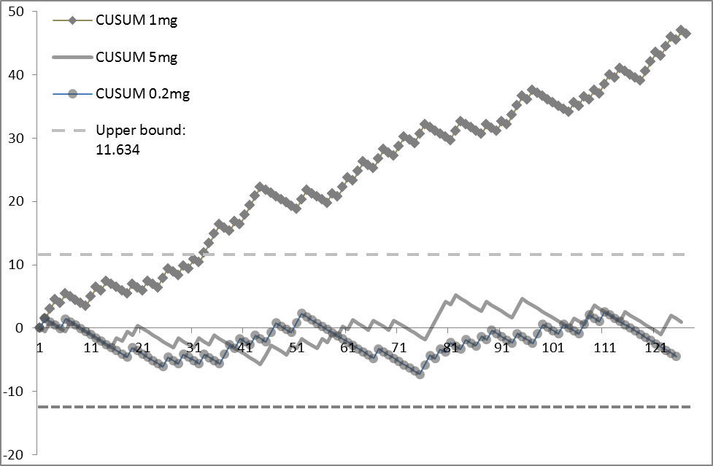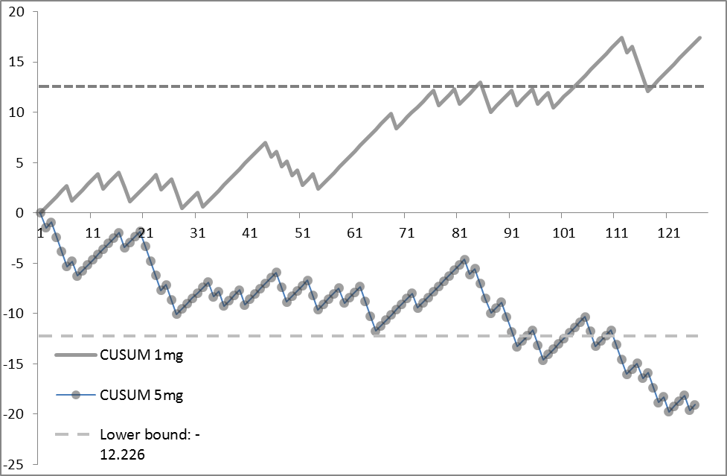
CUSUM All Cause Death
CUSUM Cardiovascular Death
References
1. Bailar JC, Byer DP. Estrogen treatment for cancer of the prostate – Early Results with 3 Doses of Diethylstilbestrol and Placebo. Cancer 1970, 26, 257-261.
- http://biostat.mc.vanderbilt.edu/wiki/Main/DataSets

